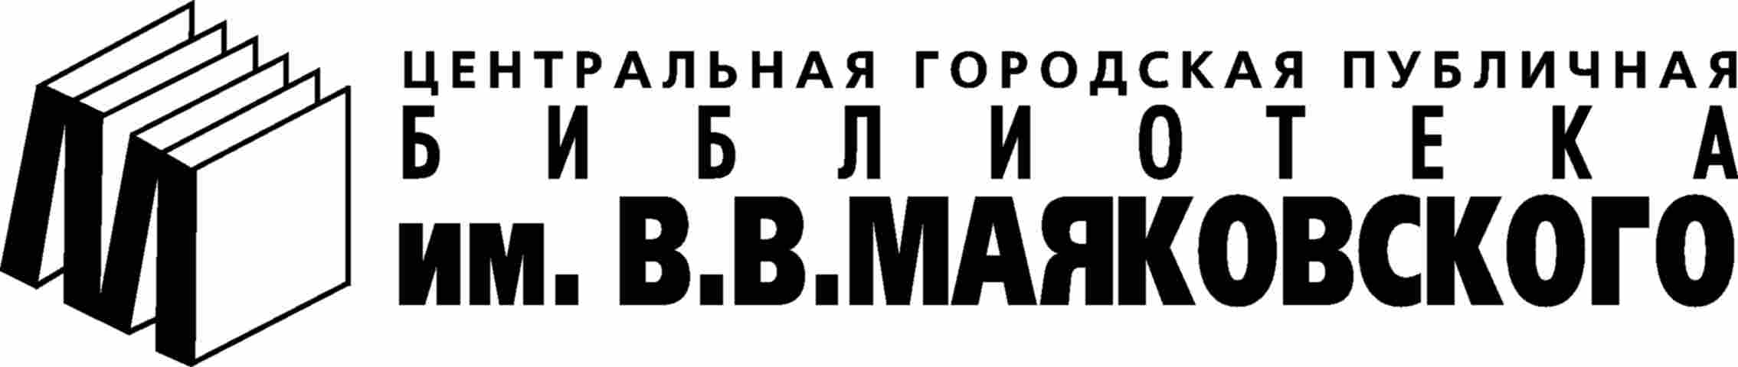

Open International Photography Contest "We and Books"

Contest Regulations

The Contest "We and Books" is set up by the Mayakovsky Central Municipal Public Library together with foreign partner libraries and supported by the All-Russia Pushkin Museum, and the newspaper “Photo-Petersburg”.
The Contest is dedicated to the 100-th anniversary of D.S. Likhachyov who contributed to development of the book culture and libraries.
The Contest is open for all those interested in the participation regardless of age, place of living or occupation on the charge-free basis.

Purpose: Promote reading and highlight the book and the library as the key elements in raising public awareness towards universal role of culture.
Objective: Produce a series of photo pictures of libraries and their users, books and their readers, librarians and private book collections featuring attitude to reading in various countries. The snapshots submitted can be of different styles: mass media-, drama- and interior-orientated etc. They can represent the architecture of an edifice housing books, diversity of books (including e-editions), their unusual design, book production procedures, or book-human relationship. We welcome the photo observations documented by professionals somehow related to the book. The best exhibits are to be on the mobile display arranged throughout the year in the libraries participating in the project as well at other expositions.
Assessment: We asses the artistic quality of the photos, their informative value and topicality.
Schedule: The Contest starts on May 27, the All-Russia Day of Libraries, to continue throughout the following 6 months. The winner will be named on November 10. And late in November, on the eve of D.S. Likhachov’s anniversary, we will inaugurate the display featuring best works and conduct awards presentation ceremony.
Upon their receipt the participating snapshots will be placed on the Mayakovsky Library web-site. Interim results news will be covered monthly in the newspaper “Photo-Petersburg”.
Prizes: Winners will be presented Award Certificates and trophies. When authorized the best works will be used in producing billboards, post cards, book marks etc. promoting and facilitating book culture.
Jury: The polling of the online web-site visitors of the library held monthly will yield a list of each stage leader. To be objective the voting procedure participation will be protected through password access.
To be displayed at the final stage exhibition the snapshots are to be selected by the panel of experts composed of photographers, arts critics and librarians.
Trophies will be awarded in the following categories:
Photography by Children (Participants aged up to 12 years old)
Photography by Teenagers (Participants aged 13-18 years old).
Photography by Amateurs
Photography by Professionals

Submitting procedure and contestant’s profile: Every contestant is allowed to present not more than 5 photos. In e-format the size should be within 800X800 pixels. (Don’t send large images. Rather downscale them through graphics editors.)
If they are interior- or documentary-oriented, the images should be accompanied with some textual information naming/identifying its idea. Subject images can also by titled at the author’s wish and expected to by accompanied by the texts (not more than 1000 characters.)
You are free to participate either under pseudonym or anonymously, which should be indicated in the application form.
Together with the image and text the applicants are to provide the following personal data: first, middle (if any), and last name, age, city/town and country of residence, whether you are an amateur or a professional in photography. The application form is attached. Feel free to send your questions concerning the contest information at the e-mail webmaster@pl.spb.ru
The snapshots for the contest can be submitted through e-mail webmaster@pl.spb.ru, brought to the library or send by post service at the following address: 46, Fontanka Emb. Room #42, 191025, St. Petersburg, Russia. Department for Cultural Events. The project coordinator Olga N. Kosogor. Contact phone 712-52-42.

